工作坊简介

创造充满生机与关爱的课堂与学校

本为期三天的互动工作坊，目的是为了加强教育者们创建让学生茁壮成长和关爱的学习环境的技巧和能力。人类的关系是建造大厦的基石。关爱、尊重、友好的关系——和自己、和学生、同事以及父母——为学生建构了必要的安全和信任的学习环境，学生不仅进行学业学习，同时也学习情感社会技能和领导技能。本工作坊采纳前沿的引领关系发展的过程，尤其是美国心理学家马歇尔博士发明的经过验证的非暴力沟通过程。

工作坊学习目标：

在三天工作坊中，参与者将练习新的技能并且加强以下能力：
- 理解所有行为的动机
- 有效地表达和处理不恰当行为
- 帮助学生理解自己并为自己的行为负责
- 全身心倾听他人，让他人感觉被听到和理解
- 诚实和友善地表达自己
- 不再将事情个人化
- 避免情绪爆发
- 用内在动机代替惩罚和奖励等外在激励
- 提出请求激发从心而发的给与
- 进行友善的沟通和互动
- 教授有效的解决问题和冲突的方法

工作坊主持人介绍
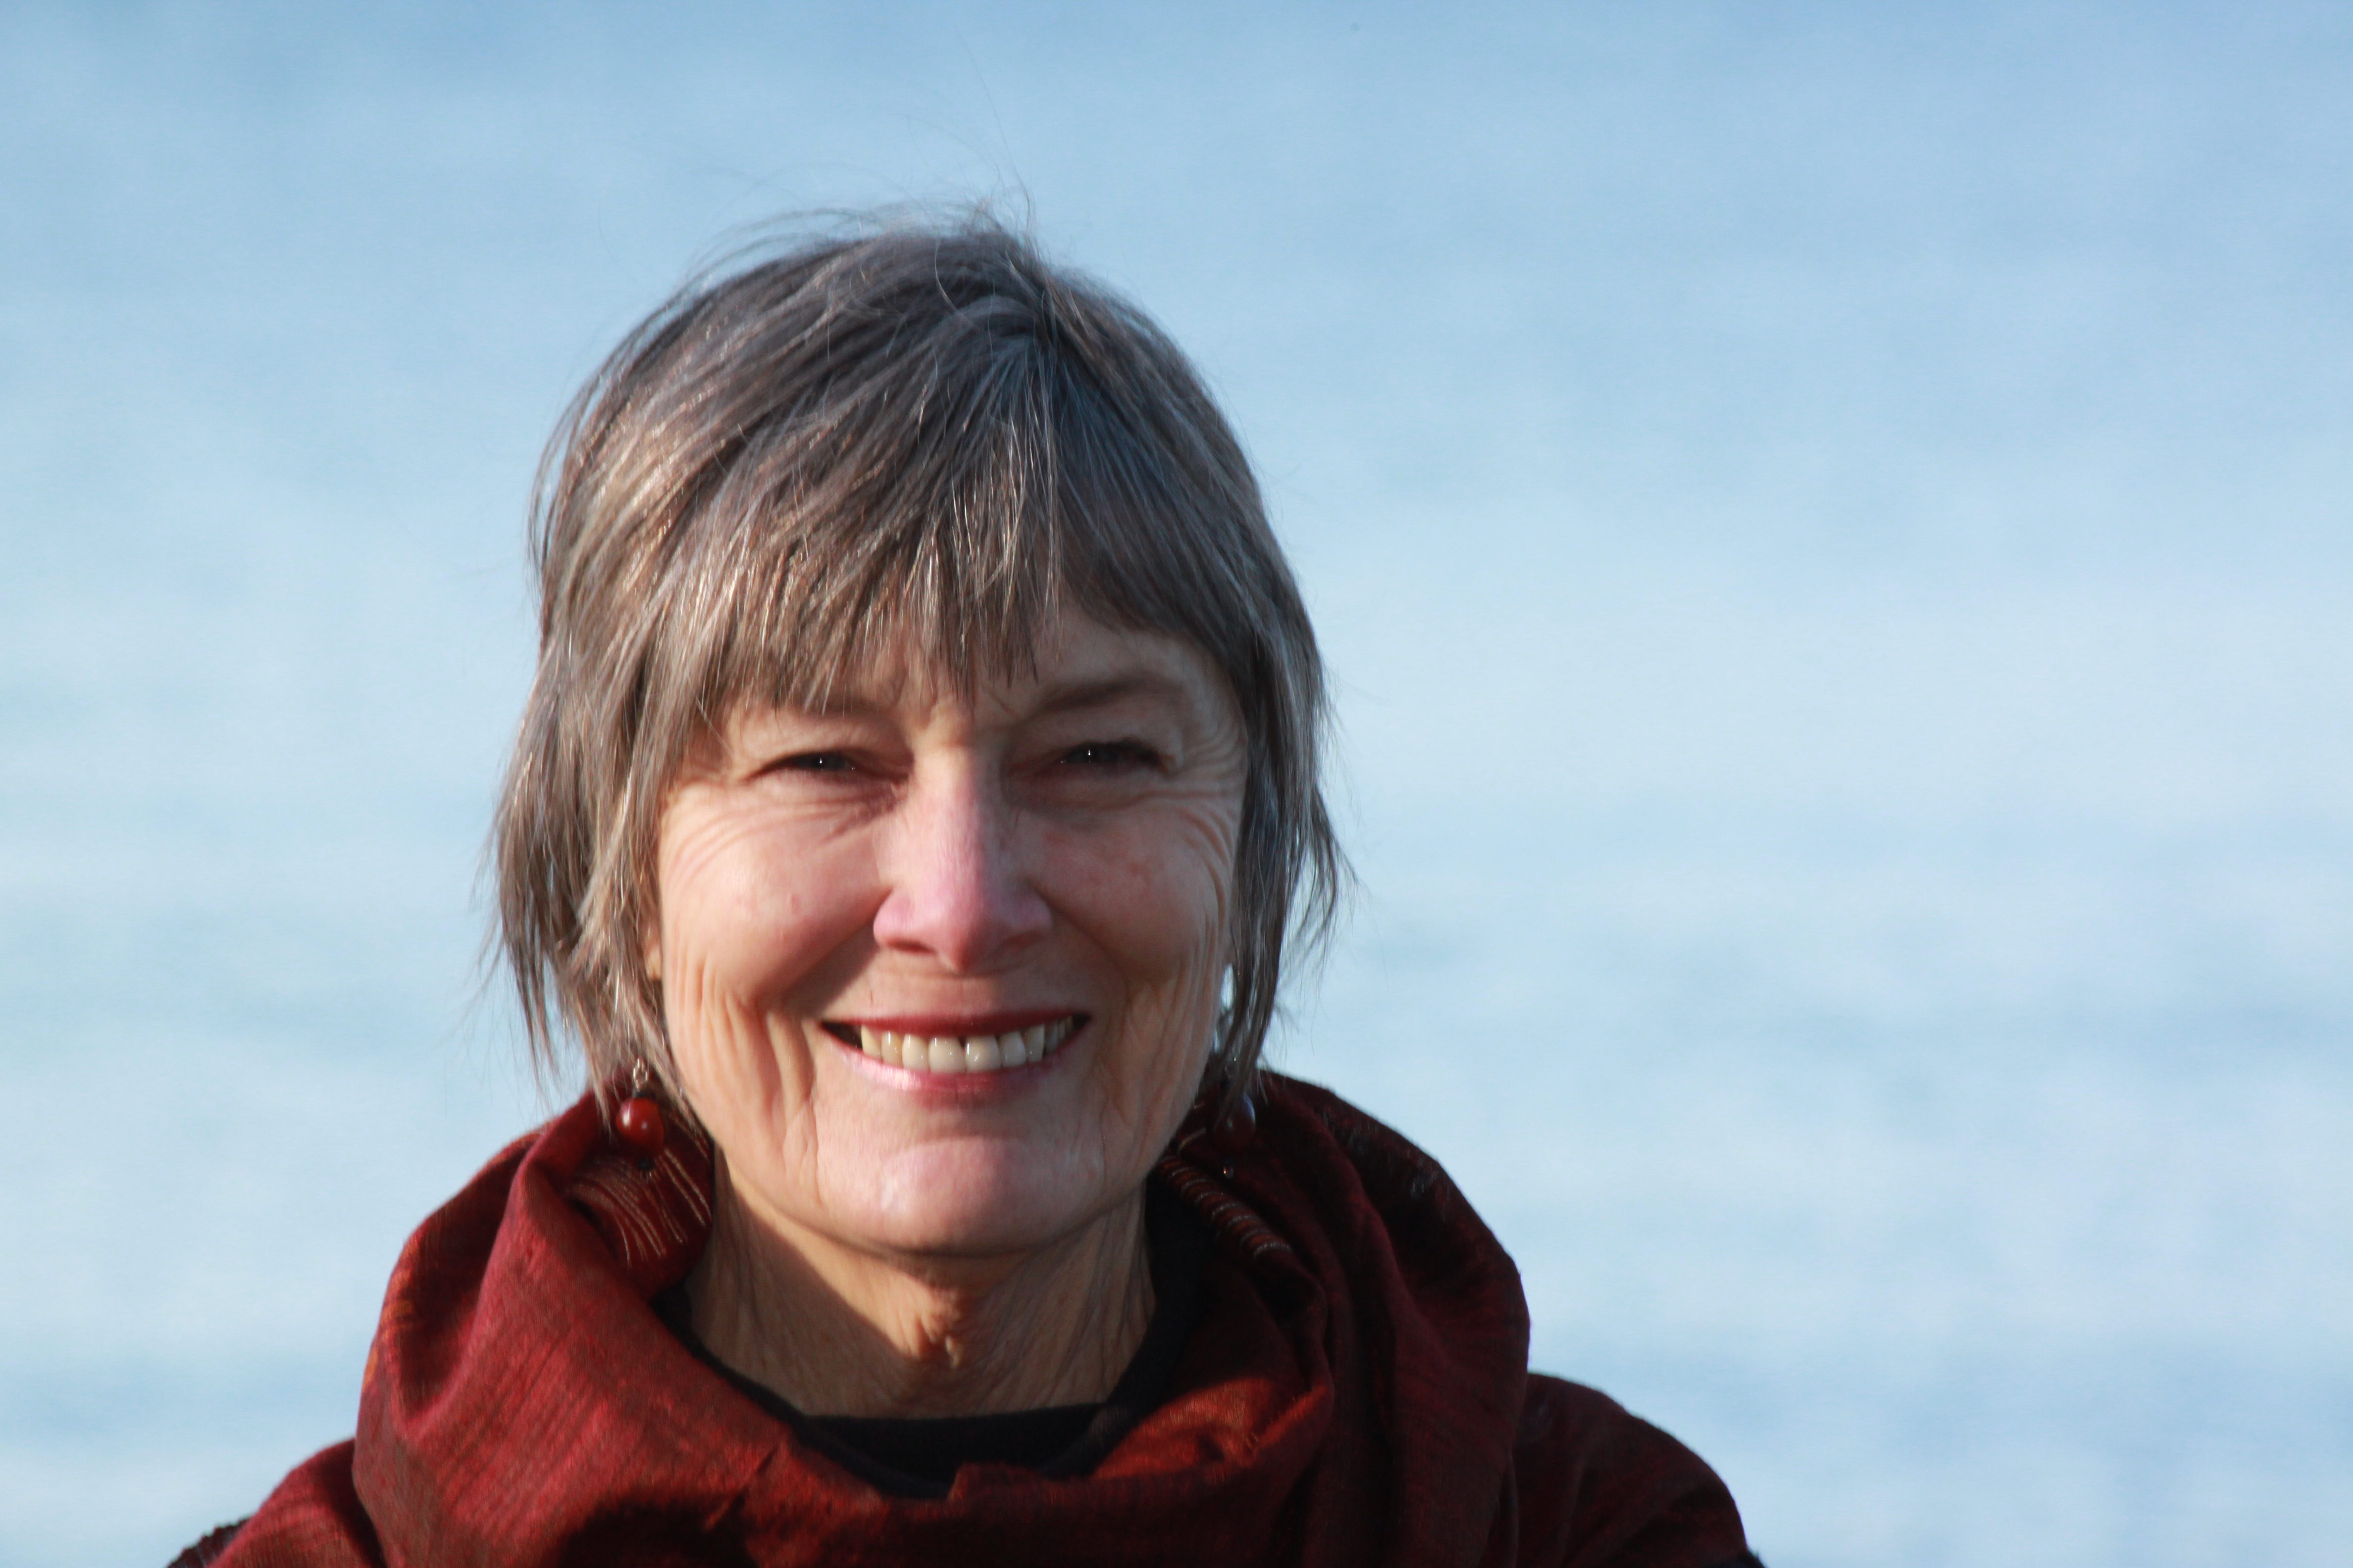
苏芮通过三十年研究和实践， 发现使用高效的方式创造的充满生机与关爱的课堂与学校——在那里，老师喜欢教学、学生不只学习学业技能同时具备自知之明、明确的价值观、互相尊重的关系、还有学习有效解决问题和冲突的合作技能。最近的研究表明这些“关系技能”对获得良好的学业表现、以及对专业领域的发展和个人成长至关重要。
苏芮在斯坦福大学开始她的文化人类学研究。随后她在美国的公立、私立学校以及青年人发展项目任教。2000年，她成为全球非暴力沟通认证培训师后，很快成为了将非暴力沟通应用到学校中的全球领导者。到目前为止，几千名来自美国、加拿大、澳大利亚、新西兰和哥斯达黎加的几千名教师和家长曾向她学习过。
苏芮和别人一起合著过三本书（由PuddleDancer出版社出版）：《关爱的课堂：关系中的教学》，《尊重的父母，尊重的孩子：将家庭冲突转化为合作的7个关键》；《没有错误的课堂：解决冲突和提升关系智能的工具》。她也和别人合作开发过一款网络沟通游戏：The No-Fault ZoneTM Gamev——一款应用在家庭、学校、商业环境中的，帮助进行清晰、互相理解和有效对话以及有效处理冲突的视觉、动觉、动手的工具。
苏芮住在西雅图，离两个女儿和一个深爱的外孙不远的海边。她经常旅行到各地举办工作坊，也通过电话和Skype提供教练和咨询。

WORKSHOP DESCRIPTION

Creating Vibrant, Compassionate Classrooms and Schools is a 3-day interactive workshop strengthening teachers’ skills and ability to create the conditions for a thriving and compassionate learning environment to grow. Our relationships are the building blocks. Caring, respectful, compassionate relationships—with ourself, and with students, colleagues, parents—strengthen community, and create the safety and trust necessary for students to learn academics as well as emotional-social skills and leadership skills. This workshop will draw upon leading edge relationship processes, especially the proven process of Nonviolent CommunicationSM developed by American psychologist, Marfshall B. Rosenberg, Ph.D.

LEARNING OBJECTIVES

In this 3-day workshop, participants will practice new skills and strengthen their ability to:
• Understand the motivation for all behavior
• Effectively address and handle troubling behavior
• Help students understand themselves and take responsibility for their behavior
• Listen empathically to others so they feel heard and understood
• Express oneself honestly and compassionately so others can hear you
• Stop taking things personally
• Avoid burnout
• Replace external motivations of punishment and rewards with intrinsic motivation
• Make requests of others that inspire natural giving
• Inspire willing cooperation
• Foster compassionate communication and interactions
* Teach effective problem solving and conflict resolution

ABOUT SURA

Sura Hart has discovered, through thirty years of study and experience, highly effective ways to create vibrant and compassionate classrooms and schools—places where teachers love to teach and where students not only learn academic skills but also learn skills for self-knowledge, values clarification, respectful relationships and collaborative skills for effective problem solving and conflict resolution. Recent studies show that these “relationship skills” are vital to achieve academic, professional and personal success.

Sura began her exploration of learning and learning communities in her Cultural Anthropology studies at Stanford University. She went on to teach in public and private schools and youth development programs in the U.S. In 2000, she became a certified trainer with the global Center for Nonviolent Communication soon thereafter, a global leader in integrating Nonviolent Communication in schools. She has now taught thousands of teachers and parents throughout the U.S., as well as in Canada, Australia, New Zealand, and Costa Rica,

Sura has co-written three books (published by PuddleDancer Press): The Compassionate Classroom: Relationship Based Teaching and Learning ; Respectful Parents, Respectful Kids: 7 Keys to Turn Family Conflict into Co-operation; The No-Fault Classroom: Tools to Resolve Conflict & Foster Relationship Intelligence. She has also co-created a communication board game: The No-Fault ZoneTM Gamev—a visual, kinesthetic, hands-on tool that is used in families, schools, and businesses to facilitate clarity, understanding, productive conversations and effective conflict resolution.

Sura’s home base is in Seattle, Washington, where she lives by the ocean, near two daughters and a cherished grandson. Sura travels frequently to give workshops, and she also provides coaching and consulting by phone and skype.

